Steps for Accessing Your Online Exam

- Minimum browser requirement: Internet Explorer 9, Firefox, or Google Chrome are required to log into the exam

- Close all programs, including email.

- Log in your LMS, Kolej ASA portal. https://lms.asa.edu.my/

- Insert your Username and Password.

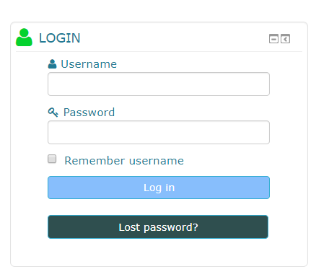

- Enter to your “My courses”. Find the exam section in the module.
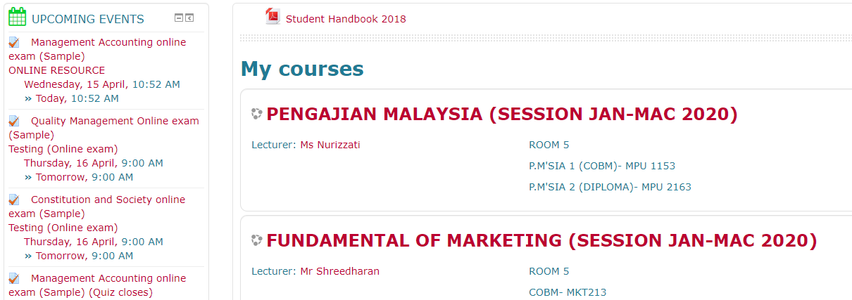

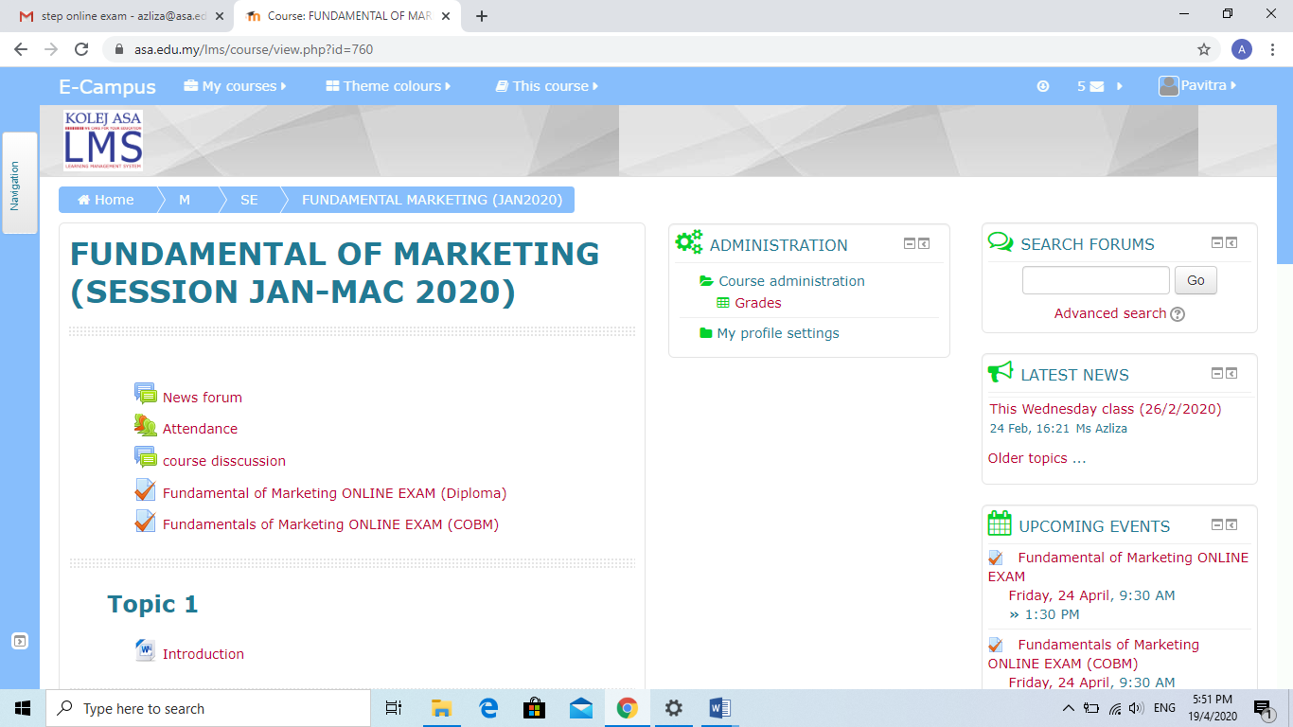

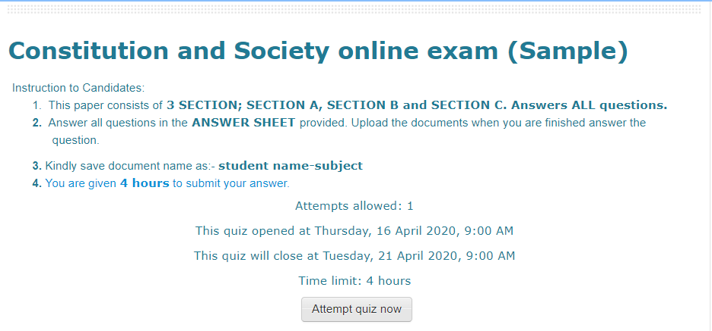
- Read the instructions and then click at “Attempt quiz now” button.

- The question will be given in the link. Click at the link to obtain the question. You will see the question in the new window.
- Use Kolej ASA Answer Sheet only during this examination.
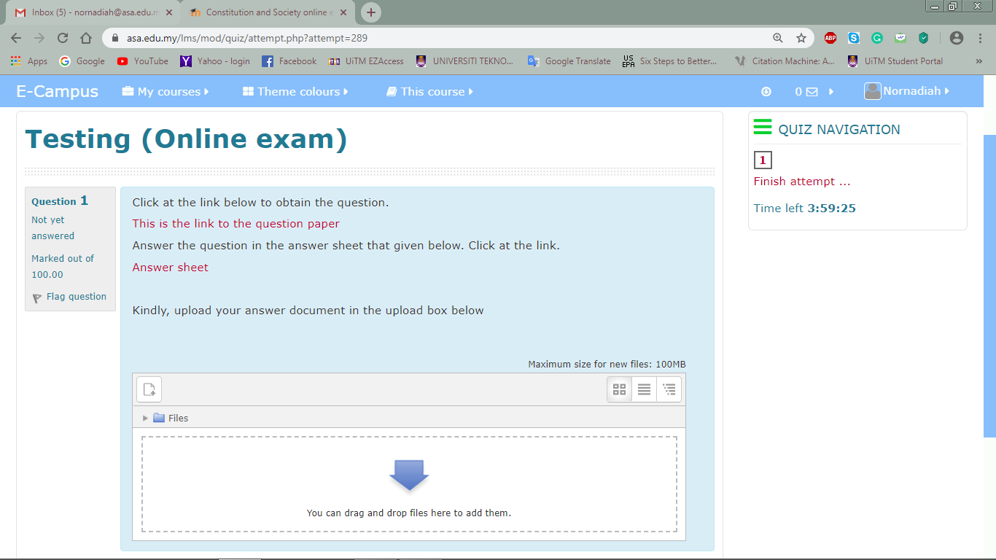

- After finished answer, upload your answer sheet in the upload box. Click “You can drag and drop files here to add them”. (Please note that in the upload box, you can upload more than one document). To ensure your answer was saved, kindly fill up with “done” in the box above upload box, do not leave it empty.
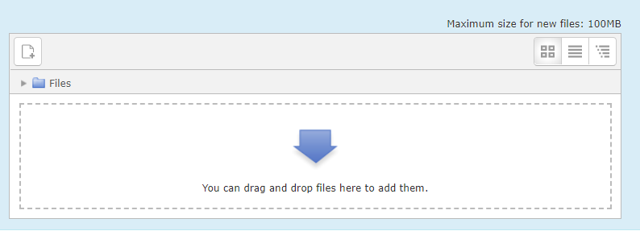

- Next, click “Upload a file” and at “Attachment” choose your document you already save. “Save as: your name-subject”. Lastly, click “Upload this file” to complete it.

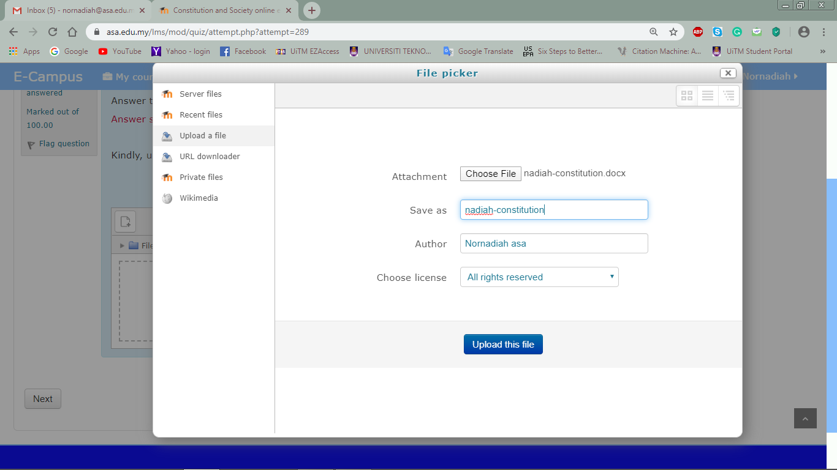

- If you want to delete document you can click at the document you upload and choose “Delete”.
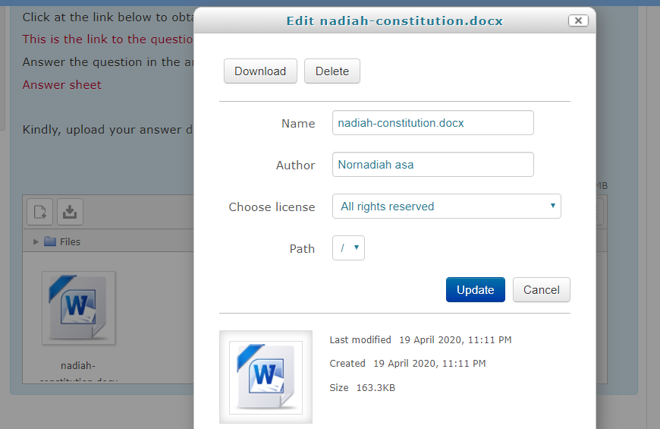

- Click “Next” at the bottom page for the next question. Then click at “Submit all and finish” button until confirmation box pop up.
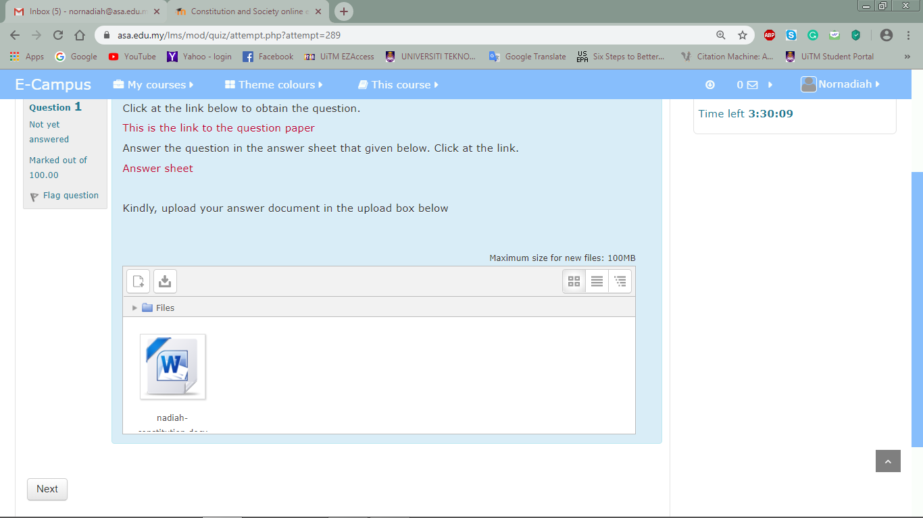

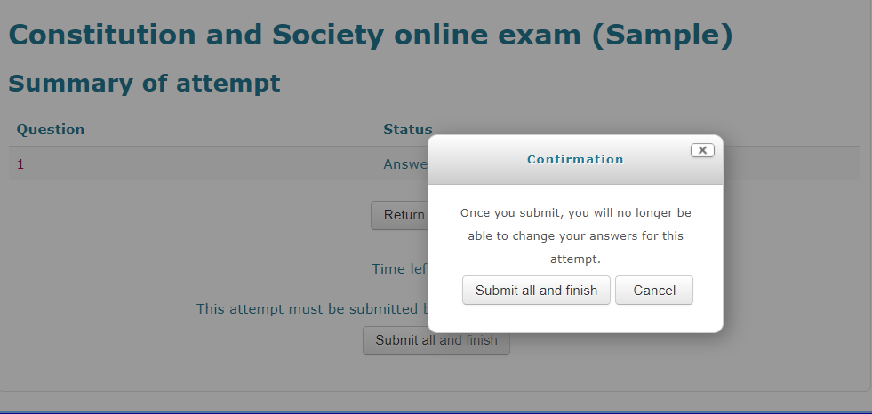

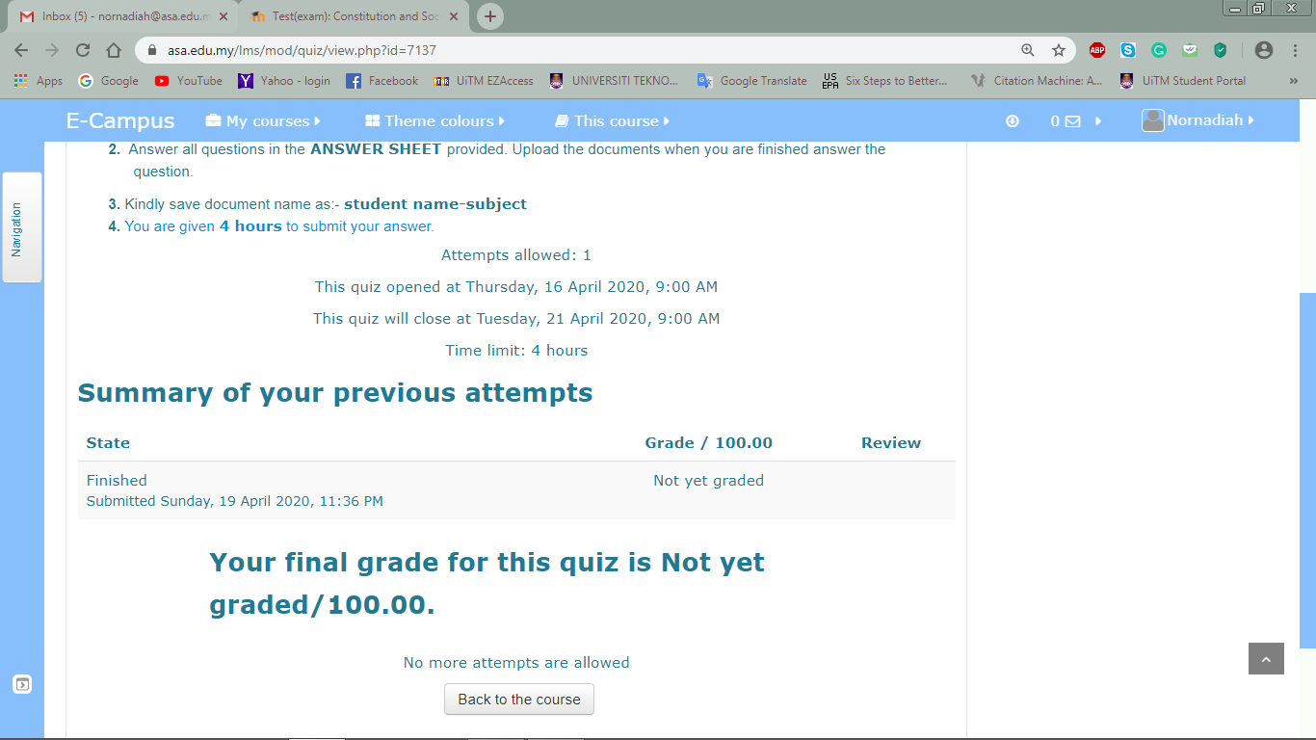
- Finished answering exam.

